**Task-2CODE**

**QUESTION**

  1- Create a component named Carousel with nested multifield-> multifield (text, path, multifield (text))

  2- Render the authored field via sling model on page using HTL

**Create a Component Named Carousel**

* **Objective:** Develop an AEM component named "Carousel" that includes a nested multifield structure. This multifield will have the following structure:
  + **Outer Multifield:**
    - **Text Field**
    - **Path Field**
    - **Inner Multifield:**
      * **Text Field**

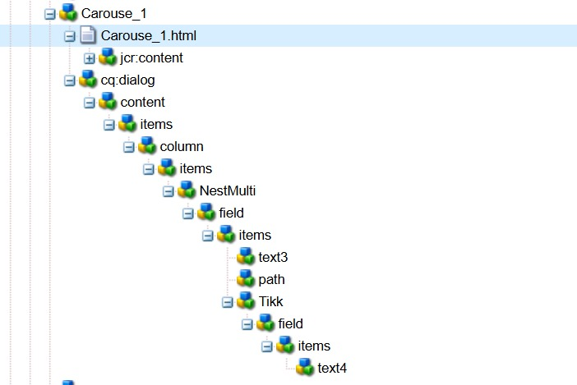

**. Render the Authored Field via Sling Model on Page Using HTL**

* **Objective:** Render the data authored in the Carousel component using a Sling Model and HTL (HTML Template Language).
* **Steps:**
  1. **Create a Sling Model:**
     + Develop a Sling Model to map the data from the Carousel component.
     + Annotate the model with @Model and map the properties.

package com.adobe.aem.guides.demo.core.models;

import java.util.List;

import org.apache.sling.api.resource.Resource;

import org.apache.sling.models.annotations.DefaultInjectionStrategy;

import org.apache.sling.models.annotations.Model;

import org.apache.sling.models.annotations.injectorspecific.ChildResource;

@Model(adaptables = Resource.class,defaultInjectionStrategy = DefaultInjectionStrategy.OPTIONAL)

public class Task_3 {

@ChildResource

private List<Mp1>nest;

public List<Mp1> getNest() {

return nest;

}

}

MULTIFIELD PROGRAM

package com.adobe.aem.guides.demo.core.models;

import java.util.List;

import javax.inject.Inject;

import org.apache.sling.api.resource.Resource;

import org.apache.sling.models.annotations.DefaultInjectionStrategy;

import org.apache.sling.models.annotations.Model;

import org.apache.sling.models.annotations.injectorspecific.ChildResource;

@Model(adaptables = Resource.class,defaultInjectionStrategy = DefaultInjectionStrategy.OPTIONAL)

public class Mp1 {

@Inject

private String text3;

@Inject

private String path;

@ChildResource

private List<Nm>tikk;

public String getText3() {

return text3;

}

public String getPath() {

return path;

}

public List<Nm> getTikk() {

return tikk;

}

}

NESTED MULTIFIELD

package com.adobe.aem.guides.demo.core.models;

import javax.inject.Inject;

import org.apache.sling.api.resource.Resource;

import org.apache.sling.models.annotations.DefaultInjectionStrategy;

import org.apache.sling.models.annotations.Model;

@Model(adaptables = Resource.class,defaultInjectionStrategy = DefaultInjectionStrategy.OPTIONAL)

public class Nm {

@Inject

private String text4;

public String getText4() {

return text4;

}

}

**Render Data Using HTL:**

* Use the Sling Model in your HTL file to render the Carousel component data

<h2>Carouse component</h2>

<h2>nothing corousel</h2>

<div data-sly-use.obj="com.adobe.aem.guides.demo.core.models.Task_3">

<div data-sly-list.object="${obj.nest}">

<p>Path :${object.path}</p>

<h3>Text :${object.text3}</h3>

<div data-sly-list.obje="${object.tikk}">

<h3>Text :${obje.text4}</h3>

</div>

</div>

</div>